**A Project Report**

**On**

**“PAVAN TEXTILES ”**

**Clothes-Based Ecommerce Website**

Project Report submitted in partial fulfilment of the requirements for the award of the degree of BACHELOR OF COMPUTER Science (BSC)



Submitted by:

Name: FarheenKhanam.M

Reg no: 20PMC32

**Under the Guidance of:**

Prof. Puneeth Kumar

Prof.Selvin Paul

Department of Computer Science

**31/ 1/ 2023**

DEPARTMENT OF COMPUTER SCIENCE &APPLICATION

St Joseph’s University

Lalbagh Road, Bengaluru – 560027

**Certificate**



DEPARTMENT OF COMPUTER SCIENCE & APPLICATION

CERTIFICATE OF COMPLETION

This is to certify that the project entitled “Pavan Textiles(cloth based E-commerce Website) ”has been satisfactorily completed by Farheen Khanam. M(20PMC32) in partial fulfilment of the award of the Bachelor of Computer Science degree requirements prescribed by St Joseph’s University Bengaluru during the academic year 2022- 2023.

Prof. Puneeth Kumar

Prof.Selvin paul

Prof. Sandhya

Head of the Department Computer Science

DECLARATION



I, Farheen Khanam.m(20PMC32) hereby declare that the project work entitled “Pavan Textiles” is an original project work carried out by me, under the guidance of Prof. Puneeth Kumar and Prof.Selvin Paul . This project work has not been submitted earlier either to any University / Institution or any other body for the fulfilment of the requirement of a course of study.

**Certificate**



This is to certify that Jithendar J (Register no:20PMC68), Karthika.K( Register no:20PMC45), Farheen Khanam (Register no:20PMC32), Urja Angre (Register no: 20PMC43) have completed the project titled “Pavan Textiles-A Cloth Based Ecommerce Website ” at St. Joseph’s University under the supervision and guidance in the fulfillment of requirements of sixth semester, Bachelor of Science (Computer Science) of Bengaluru City University, Bengaluru.

Prof . Puneeth Kumar

Prof. Sandhya

Head of the Department Computer Science

**Acknowledgment**

The success of the project depends upon the efforts invested. It’s my duty to acknowledge and thank the individuals who has contributed in the successful completion of the project.

I take this opportunity to express my profound and whole hearted thanks to Rev. Fr. Dr.Victor Lobo SJ , Principal, St. Joseph’s College, Bangalore and Rev.Fr. Denzil Lobo SJ , Director , St. Joseph’s Institute of Information Technology (SJIIT) for providing ample facilities made to undergo my project successfully.

I express my deep sense of gratitude and sincere thanks to our Head of the Department Prof. N. Sandhya for her valuable advice.

I feel immense pleasure to thank my respected guides Prof Sandhya for sustaining Interest and providing dynamic guidance in aiding me to complete this project immaculately and impeccably and for being the source of my strength and confidence.

It is my duty to express my thanks to all Teaching and Non-Teaching Staff members of Computer science department who offered me help directly or indirectly by their suggestions. The successful completion of my project would not have been possible without my parent’s Sacrifice, guidance and prayers. I take this opportunity to thank everyone for their continuous Encouragement. I convey my thankfulness to all my friends who were with me to share my happiness and agony. Last but not the least I thank almighty God for giving me strength and good health throughout my project and enabling me to complete it successfully.

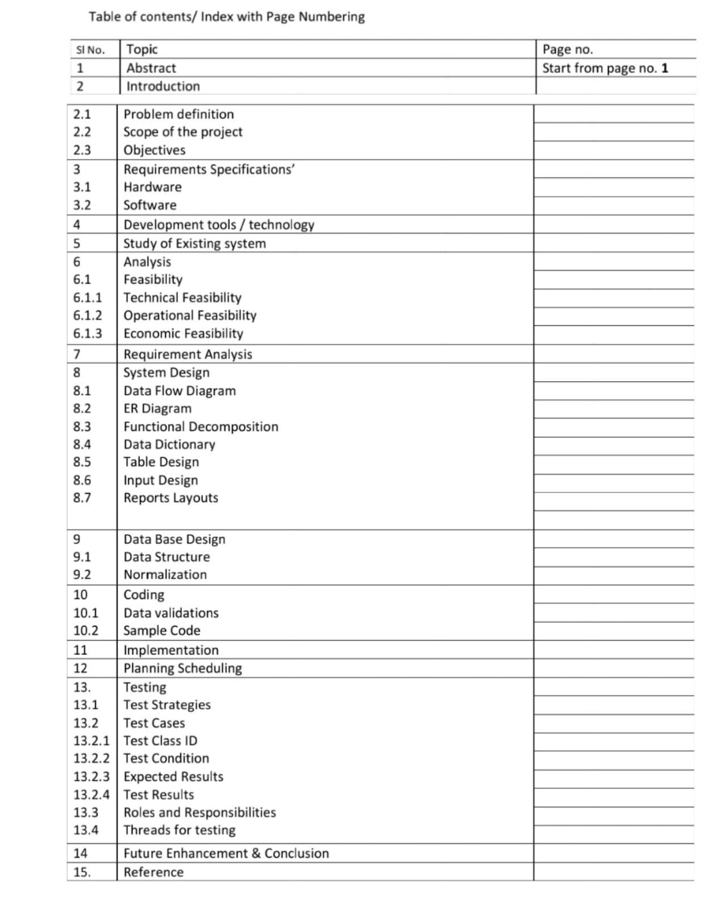

**Abstract**:

Electronic Commerce site consist of purchasing and selling products which is intended to benefit both retailers and users. This platform aims to help the local shopkeepers in selling their clothes through online and to provide a more convenient and more reliable way for users to find, view and buy the desired clothes that are suitable for their necessity, the customers can also get description and details from online. Problems found that most retailers had a hard time in selling their clothes, in reaching their customer and the insufficient specification of clothes such as design, color specifications that the possible buyer might experience. We tried to make one demo survey by knowing what exactly is the need of the hour. We came up with the conclusion that people are more confused on there choice. Their choice and comfort are totally different. Many people are just filling their wardrobes with random dresses.

Second factor was Budget Some designer dresses and suits are expensive because of their rare availability. People follow the trend and just end up buying lump sum clothes and after which they aren’t worn and instead complain that it’s wrong purchase. Well due to lack of knowledge about their choice behaviour , costumers don’t know what and where is the right place for each costume .We tried to come up with constant service so that we reach customer satisfaction factor.

**Introduction**

One primary reason to come up with this cloth e-commerce website is to increase the reachability to more number people over internet. E-commerce shops have become part of our daily lives. Technological advancement has made it possible for people to sit in the convenience of their homes and still shop online without going to a physical shop.

“PAVAN TEXTILES”, a renowned clothing store located in WHITEFIELD, Bengaluru. This store offers a wide variety of clothes for people of all age groups, from infant to the old, whatever you wish for, this store has it all.

PAVAN TEXTILES was established in the year 2000, and has been running since then for a good 21 years till date. It has become one of the favorite shopping spots for the people in Whitefield. After a great success of the store, the owners wanted to spread their network not only in Whitefield but also across whole of Bengaluru. Our team took the initiative of building a website for PAVAN TEXTILES so that they could attract more and more customers from the whole of Bengaluru.

The shopping store system includes details of all the types of outfits for both men and women and even accessories available in the store. This software will also help provide the management of the store with a full-fledged, automatic computerized billing system, and an organized database system for the smooth working of the transactions. The software has the facility to give a unique id for every customer and at the details of every customer and the staff automatically gets stored in the database. User can also check the availability of desired clothing at the store, details like price, color of the clothing and also avail exchange facilities online!

The clothing store management System has a login-logout system for the users and an admin panel for the management. It is accessible by the admin. Only they can add data to the database. The data can be retrieved easily. The interface is very user- friendly. The data are well protected for personal use and makes the processing very fast.

The main motive of our project is to build a website for the cloth store for its proper management and smooth functioning.

Scope of Project

Our website has a sign in and sign up page, home page, about us page, contact us page and explore now page.

Login and sign up page take the user input I.e. the user information. Validation has been given to this page. Home page is further categorized into women and men wear which includes sports wear, traditional, winter wear, party wear. Where user can view the product price and details. More details about clothes such as it's size and colors. Further, the user can add the dress to cart and proceed buying it. The customer can buy multiple number of same cloth. About us page contains the detail review about our website. In contact us page , we have provided contact details where any customer can contact for servicing.

One primary reason to come up with this plantation e-commerce website is to increase the reachability to more number people over internet. E-commerce shops have become part of our daily lives. Technological advancement has made it possible for people to sit in the convenience of their homes and still shop online without going to a physical shop. Logistically, a consumer finds a product more interesting and attractive when they find it on the website of a retailer directly and are able to see item’s details online. The customers of today are not only attracted because online shopping is very convenient, but also because they have broader selections, highly competitive prices, better information about the product (including people’s reviews) and extremely simplified navigation for searching regarding the product.

Moreover, business owners often offer online shopping options at low rates because the overhead expenses in opening and running a physical store are higher than a website. The retailers can directly reach the customers. We sell the high quality plants with returnable policy. The damaged plants and the dried plants can be returned.

**Study of Existing System**:-

EXISTING SYSTEM

The fashion industry is one line of work that will always be in business ,however there are several things we need to add for starting a best clothing boutique for all types.An online shopping system is a process in which people (specifically customers) are being provided with the option of purchasing goods and services directly from the seller, all in a real-time environment. Online shopping is an application of the internet as electronic commerce. From the business perspective, customers usually find the products more attractive, on websites, as they get all the details available there.

The E-commerce Management System has various flaws in it as because of which most of the people don’t use the system even though it has several advantages over traditional stores. The biggest problem is that it takes at least a day to deliver a product to the customer. While some other issues are a duplication of the product means the product is shown on the web some time differs with the original product due to which next time that customer go to buy the product through the traditional type of store.

In the present scenario, the biggest market for this (online shopping) business is by highly educated people, mostly. This system has been designed keeping in mind all the aspects such as loading the data, complexity, and maintaining the security of user credentials. Here in this system, complexity refers to the total number of features being provided to users, and their smooth arrangement and functioning required.

The shop owner can appoint officials particularly to handle this, who will help the owner in managing the customers and product orders. The system also endorses a home delivery system for delivering the purchased products.

Select and research our target market. Styles and fashion trends vary depending on age, gender, lifestyle and geographical location, so gain a deep understanding of what people are looking for in apparel. Contact consumers, suppliers, designers and even competitors to learn about trends and help decide your market focus.

The main objective of this project is to develop a web-oriented application that can provide an online shopping platform for all kinds of clothing and textiles.

PURPOSING PLAN

*.Our business plan is priority one, as it represents our goals essentially our road map to achievement.

*. The business plan will include an executive summary, financial aspects of the company. *.We will also include any applicable investor information, details about products and services we intend to offer and marketing information.

*.Stick to our business plan when purchasing equipment and supplies.

*.We Stay on top of current fashion trends and make sure we give you enough time and proper online service to purchase seasonal items from our suppliers.

*.An online clothing store that allows you to create it from scratch to meet business needs.

*Easy to use website with simple and creative functionality

*Realistic Product Pricing for the users concerning the market prices.

*.Websites developed are adequately tested and validated.

**Software Requirements**

1.Operating System: Windows 11 ultimate which supports networking

2. Language s Used :HTML,CSS ,Java Script

3. Web Browser: Microsoft Internet Explorer, Mozilla, Google Chrome

**Hardware Interface**

1.Processor: INTEL® CORE™

2.Ram :16.0GB (15.7GB usable)

3.Type: 64-bit Operating System *64 Based Processor

4.Hard Disk: 320GB